**Face Recognition - Attendance System**



**UNIVERSITY OF ENGINEERING**

**&**

**MANAGEMENT, JAIPUR**

**Face Recognition - Attendance System**

Submitted in the partial fulfillment of the degree of

**BACHELOR OF TECHNOLOGY**

In

**COMPUTER SCIENCE & ENGINEERING (AI&ML)**

Under

**UNIVERSITY OF ENGINEERING & MANAGEMENT, JAIPUR**

**BY:-**

NITIN ROY (12020002001116)

UNDER THE GUIDANCE OF

**Prof. Debajyoti Chatarjee**

COMPUTER SCIENCE & ENGINEERING



UNIVERSITY OF ENGINEERING & MANAGEMENT, JAIPUR

**Approval Certificate**

This is to certify that the project report entitled “**Online Face Recognition Attendance System**” submitted by  **(I) YASH RAJ ANAND (12020002001016), (II) RISHABH (12020002001018)** in partial fulfillment of the requirements of the degree of **Bachelor of Technology** in **Computer Science & Engineering (AI &ML)**  from University **of Engineering and Management, Jaipur** was carried out in a systematic and procedural manner to the best of our knowledge. It is a bona fide work of the candidate and was carried out under our supervision and guidance during the academic session of 2020-2024.

_______________________

**Prof. Debajyoti Chatarjee**

Project Guide, Associate Professor (CSE)

UEM, JAIPUR

_______________________ ______________________

**Prof. Mrinal Kanti Sarkar Prof. A Mukherjee**

HOD (CSE) Dean

UEM, JAIPUR UEM, JAIPUR

**ACKNOWLEDGEMENT**

The endless thanks go to Prof. (DR.) G. UMA DEVI for all the blessings she has showered onto me, which has enabled me to write this last note in my research work. During the period of my research, as in the rest of my life, I have been blessed by Almighty with some extraordinary people who have spun a web of support around me. Words can never be enough in expressing how grateful I am to those incredible people in my life who made this thesis possible. I would like an attempt to thank them for making my time during my research in the Institute a period I will treasure. I am deeply indebted to my research supervisor, Prof. (DR.) G. UMA DEVI me such an interesting thesis topic. Each meeting with him added in valuable aspects to the implementation and broadened my perspective. He has guided me with his invaluable suggestions, lightened up the way in my darkest times and encouraged me a lot in the academic life.

Nitin Roy (12020002001116)

**ABSTRACT**

The rapid advancement of technology has revolutionized traditional attendance tracking systems, leading to the development of innovative solutions that enhance accuracy, efficiency, and security. This abstract introduces an Online Face Recognition Attendance System, a cutting-edge application designed to streamline and modernize the process of attendance management.

The proposed system leverages state-of-the-art facial recognition technology to automate the attendance tracking process. By employing advanced algorithms and deep learning techniques, the system identifies and verifies individuals based on unique facial features. This eliminates the need for traditional methods such as manual entry, swipe cards, or biometric devices, providing a seamless and contactless experience.

Key features of the Online Face Recognition Attendance System include:

1**. Biometric Accuracy**: The system ensures a high level of accuracy by analysing distinctive facial attributes, preventing instances of proxy attendance and unauthorized access.

2. **Real-time Recognition**: Leveraging real-time facial recognition capabilities, the system enables instant and on-the-fly identification, facilitating timely and accurate attendance recording.

4**. User-Friendly Interface**: The intuitive user interface caters to both administrators and end-users, providing a seamless experience for attendance management. Users can easily view their attendance records, while administrators can monitor and manage attendance data efficiently.

5. **Integration with Existing Systems**: The system is designed to integrate seamlessly with existing school, college, or organizational databases, minimizing disruption during implementation.

6. **Privacy and Security**: To address concerns related to privacy, the system adheres to industry-standard security protocols, ensuring that facial data is encrypted, stored securely, and accessible only to authorized personnel.

By implementing the Online Face Recognition Attendance System, institutions and organizations can streamline attendance management processes, reduce administrative overhead, and enhance overall security. The integration of facial recognition technology represents a step forward in the evolution of attendance tracking systems, aligning with the demands of the modern digital era.

# Table of Contents

* + - 1. **Introduction………………………………………………….3-7**

**1.1What is it?.............................................................................3-5**

**1.2Aim & objective……………………………………………6-7**

* + - 1. **Experimental Setup…………………………………………8-11**

**2.1 Minimum Requirement………………………………..8**

**2.2 VS Code………………………………………………...8**

**2.3 Python3…………………………………………………9**

**2.4 Language Used (Python)………………………………9**

**2.5 MODULES USED……………………………………..10-11**

* + - 1. **Proposed Model………………………………………………12-13**
      2. **Working Methodology……………………………………….14**
      3. **Testing & Result……………………………………………...15-19**
      4. **Screenshots of Applied Code…………………………...……15-19**
      5. **Conclusion & Future Scope………………………………….20**

**List of Figures**

Figure 3.2 Visual Studio code logo………………………………………………………….08

Figure 3.3 Python logo………………………………………………………………………09

Figure 3.4.1 Python Logo……………………………………………………………………09

Figure 5.1 Code Image 1…………………………………………………………………….15

Figure 5.2 Code Image 2…………………………………………………………………….16

Figure 5.3 Code Image 3…………………………………………………………………….16

Figure 5.4 Code Image 4…………………………………………………………………….17

Figure 5.5 Output Image 1…………………………………………………………………..18

Figure 5.6 Output Image 2…………………………………………………………………..18

Figure 5.7 Output Image 3…………………………………………………………………..18

## 1.CHAPTER

## INTRODUCTION

## What is Online Face Recognition Attendance System?

## The Online Face Recognition Attendance System represents a cutting-edge advancement in attendance management, harnessing the power of facial recognition technology to revolutionize the way organizations track and monitor attendance. At its core, the system begins with the enrollment phase, where individuals are registered by capturing their facial features, generating unique biometric templates that serve as digital signatures for identification. These templates are securely stored in a database, forming a comprehensive reference for real-time comparisons during attendance tracking. When users seek to mark their attendance, the system employs sophisticated algorithms to analyze facial data captured through cameras or webcams. This real-time recognition process ensures a swift and accurate identification of individuals, mitigating the risk of errors and fraudulent attendance. The system's efficiency lies in its ability to seamlessly integrate with existing databases, providing a user-friendly and contactless experience. Administrators benefit from real-time monitoring capabilities, allowing for proactive intervention and decision-making. Beyond its operational advantages, the system prioritizes privacy and security, employing robust measures to encrypt and protect facial data. As a result, this technology finds versatile applications across sectors, from educational institutions to corporate environments, offering a comprehensive solution that enhances accuracy, efficiency, and security in attendance management.

## 1.2 Our Idea

In the theoretical conceptualization of an Online Face Recognition Attendance System using Python, the implementation unfolds through a multi-faceted approach. The foundational step involves employing a facial detection library or algorithm, such as Dlib or OpenCV, to identify and locate faces within an image or video stream. Subsequently, a face recognition model comes into play, extracting distinctive facial features and descriptors from the detected faces. Dlib's face recognition model, for instance, computes face descriptors that serve as unique biometric templates for individuals. The theoretical framework incorporates a comprehensive database management system, where each enrolled individual's facial features are stored securely. During the enrollment process, facial data is captured, encoded into face descriptors, and subsequently stored in this database.

The real-time recognition aspect of the system is executed by continuously capturing video frames from a webcam or camera feed. Each frame undergoes face recognition processing, comparing the extracted features with the entries in the database. Upon a successful match, the system logs the attendance for the recognized individual, marking their presence for that specific timestamp. The theoretical system also encompasses a user-friendly interface, possibly developed using Python libraries such as Tkinter or PyQt. This interface would provide a graphical representation of the video feed, recognized faces, and the corresponding attendance status.

Security measures are paramount within this framework, requiring the implementation of robust protocols to safeguard against unauthorized access and protect the privacy of facial data. Encryption of stored data, access controls, and secure communication channels are integral components of this security layer. Additionally, the system should be designed with considerations for error handling and logging, ensuring the capture and reporting of any issues that may arise during its operation.

Furthermore, the theoretical framework acknowledges the necessity for seamless integration with existing organizational databases or management systems, facilitating a cohesive operational environment. The deployment phase involves configuring hardware requirements, network settings, and access permissions to ensure the system's smooth integration into the targeted environment. Ethical considerations, including the responsible use of facial recognition technology and compliance with privacy regulations, are inherent in the system's development and deployment, reinforcing its ethical and legal soundness within the broader context of technological applications.

1. **AIMS & OBJECTIVE**

**Aim:**

The primary aim of the Online Face Recognition Attendance System is to modernize and optimize the process of attendance management by leveraging facial recognition technology. The system aims to provide a seamless, accurate, and contactless method for identifying and recording individuals' attendance in various settings such as educational institutions, corporate environments, or any organization where attendance tracking is essential. By automating the attendance process through advanced facial recognition algorithms, the system aspires to enhance efficiency, eliminate manual errors, and contribute to a secure and convenient experience for both administrators and users.

**Objectives:**

1. **Accuracy and Precision**: Develop and implement facial recognition algorithms that ensure a high level of accuracy and precision in identifying individuals, minimizing the occurrence of false positives or negatives in attendance tracking.

2. **Efficiency and Automation**: Streamline the attendance management process by automating the identification and recording of attendance through real-time facial recognition. Aim for a system that operates efficiently, reducing the time and effort traditionally associated with manual attendance tracking methods.

3. **Contactless Experience**: Prioritize a contactless experience for users, especially in contexts where hygiene and health considerations are crucial. Eliminate the need for physical contact or the use of additional devices for attendance marking.

4. **Security and Privacy**: Implement robust security measures to protect the facial data and ensure that access to attendance records is granted only to authorized personnel. Adhere to privacy regulations and ethical considerations in handling biometric information.

5. **User-Friendly Interface**: Design an intuitive and user-friendly interface for both administrators and end-users. Ensure that the system is easy to navigate, providing a positive experience for individuals marking attendance and administrators managing the system.

6. **Integration with Existing Systems**: Enable seamless integration with existing organizational databases or management systems, allowing for the smooth adoption of the facial recognition attendance system into the broader infrastructure.

7. **Real-time Monitoring and Reporting**: Provide administrators with real-time monitoring capabilities, allowing them to track attendance data instantly. Implement automated reporting features to generate comprehensive attendance reports, offering insights into attendance trends, patterns, and exceptions.

8. **Scalability**: Design the system to be scalable, accommodating the varying needs of different organizations and institutions. Ensure that the system can handle increases in the number of users and attendance data without compromising performance.

9. **Adaptability**: Build flexibility into the system to adapt to different environments, lighting conditions, and user demographics. Account for potential challenges in facial recognition and implement solutions that enhance adaptability.

10. **Educational Outreach**: Conduct educational initiatives to inform users and administrators about the benefits, functionalities, and ethical considerations associated with the Online Face Recognition Attendance System. Foster understanding and acceptance within the user community.

**3. EXPERIMENTAL SETUP**

**3.1 Minimum requirement: -**

(i) windows 7 OS

(ii) 4 GB Ram

(iii) 160 GB Hard disks

(iv) working internet Connection

**SOFTWARE SETUP**

**3.2 VISUAL STUDIO CODE**



Visual Studio Code is a distribution of the Code - OSS repository with Microsoft-specific customizations released under a traditional Microsoft product license. Visual Studio Code combines the simplicity of a code editor with what developers need for their core edit-build-debug cycle. It provides comprehensive code editing, navigation, and understanding support along with lightweight debugging, a rich extensibility model, and lightweight integration with existing tools. Visual Studio Code is updated monthly with new features and bug fixes. You can download it for Windows, macOS, and Linux on Visual Studio Code's website. To get the latest releases every day, install the Insiders build.

**3.3 Python3**



Python 3 is the latest iteration of the Python programming language,One of the notable changes is the transition from the `print` statement to the `print()` function, promoting a more consistent syntax and encouraging the use of parentheses. Python 3 also addresses Unicode support comprehensively, making it the default string type and mitigating encoding-related issues present in Python 2. The division of integers now results in floating-point numbers by default, enhancing the language's intuitiveness. Moreover, Python 3 introduces features like advanced string formatting with f-strings and the `format()` method, providing more powerful and readable options. Other notable enhancements include a redesigned `range()` function, dictionary views for improved memory efficiency, and the adoption of type hints for better code documentation. With built-in support for asynchronous programming through the `async` and `await` keywords, Python 3 caters to contemporary development practices.

**3.4 LANGUAGES USED**

**3.4.1 Python**



Python 3 is the latest version of the Python programming language, succeeding Python 2. It brings improvements like the transition to the `print()` function, enhanced Unicode support, and default floating-point results for integer division. Python 3 introduces advanced string formatting with features such as f-strings and the `format()` method. Additionally, it adopts modern practices with asynchronous programming support through the `async` and `await` keywords. The end of Python 2's life has made Python 3 the recommended and actively developed version, emphasizing its commitment to staying relevant and aligned with contemporary programming standards.

# 3.5 MODULES USED

**3.5.1 Tkinter:** Tkinter is the standard GUI (Graphical User Interface) toolkit that comes with Python. It provides a set of tools for creating desktop applications with a graphical interface, making it user-friendly and interactive. Tkinter is easy to use, making it a popular choice for developing GUI applications in Python, from simple windows to more complex applications.

**3.5.2 Messagebox:** The `messagebox` module is part of the Tkinter library in Python and is used for creating pop-up message boxes in GUI applications. It provides a convenient way to display informational messages, warnings, errors, or to prompt the user for input. The module includes functions like `showinfo()`, `showwarning()`, `showerror()`, and `askquestion()`, allowing developers to easily incorporate user-friendly message boxes in their Tkinter applications.

**3.5.3 tkinter.simpledialog:** The `tkinter.simpledialog` module is a part of the Tkinter library in Python and provides a simple and consistent way to create dialogs for user input. It includes classes such as `askstring()`, `askinteger()`, and `askfloat()` that allow developers to prompt users for string, integer, or floating-point input, respectively. This module is particularly useful for gathering user information or confirming actions in GUI applications with minimal coding effort.

**3.5.4 cv2 (OpenCV)**: The `cv2` module is a part of the OpenCV (Open Source Computer Vision) library, a powerful computer vision and image processing library in Python. `cv2` provides functions for tasks like image and video processing, feature detection, and object recognition. It is widely used in computer vision applications, including robotics, machine learning, and augmented reality.

**3.5.5 os**: The `os` module is a part of the Python standard library and provides a way to interact with the operating system. It offers functions for tasks such as file and directory manipulation, executing system commands, and handling environment variables. The `os` module is essential for creating platform-independent code that can work seamlessly across different operating systems.

**3.5.6 csv**: The `csv` module in Python is part of the standard library and facilitates the reading and writing of Comma-Separated Values (CSV) files. It provides functionality to parse data from CSV files and convert data structures, such as lists or dictionaries, into CSV format. This module is widely used for handling tabular data, making it a versatile tool for tasks like data analysis, data import/export, and database interactions in Python applications.

**3.5.7 NumPy**: NumPy is a fundamental numerical computing library for Python. It provides support for large, multi-dimensional arrays and matrices, along with a collection of mathematical functions to operate on these arrays. NumPy is a cornerstone in scientific computing and data analysis in Python, offering efficient and fast operations on arrays. It serves as the foundation for many other libraries and tools in the Python ecosystem, making it a crucial component for tasks like linear algebra, statistical analysis, and machine learning.

**3.5.8 pandas**: Pandas is a powerful open-source data analysis and manipulation library for Python. It provides data structures, such as DataFrame and Series, that make it easy to work with structured data and perform various operations like filtering, grouping, and reshaping. Pandas is widely used in data science, statistics, and finance for tasks like data cleaning, exploration, and analysis. Its functionality complements NumPy and is a key component in the Python ecosystem for handling tabular and time-series data efficiently.

**3.5.9 datetime**: The `datetime` module in Python is part of the standard library and provides classes for working with dates and times. It includes the `datetime` class for representing dates and times, `date` class for dates, `time` class for times, and `timedelta` class for representing the difference between two dates or times. The `datetime` module enables developers to perform various operations, such as parsing and formatting dates, arithmetic operations on dates, and extracting components like days or months. It is a fundamental module for handling temporal data and is commonly used in applications involving scheduling, logging, and data analysis.

**3.5.10 time**: The `time` module in Python is part of the standard library and provides functions for working with time-related operations. It includes functions for measuring time intervals, getting the current time, and formatting time values. The `time` module is commonly used for tasks such as benchmarking, performance monitoring, and introducing delays in code execution. It is a fundamental module for handling time-related functionality and plays a crucial role in scenarios where precise timing or scheduling is required in Python applications.

**4.** **PROPOSED MODEL**

The proposed model for the Online Face Recognition Attendance System is designed to address the current limitations of traditional attendance management systems by integrating cutting-edge facial recognition technology. This model envisions a robust and efficient system that streamlines the attendance tracking process while ensuring accuracy, security, and user convenience. The key components of the proposed model include:

1. Facial Recognition Algorithm: Utilize advanced facial recognition algorithms, potentially based on deep learning techniques, to accurately identify and verify individuals. The model may leverage pre-trained neural networks or custom-trained models to extract unique facial features for precise attendance tracking.

2. Biometric Data Storage: Implement a secure and centralized biometric data storage system where facial templates or encodings are securely stored. Prioritize encryption mechanisms to protect the privacy and integrity of the stored facial data.

3. Real-time Processing: Enable real-time processing of facial data to facilitate instant attendance tracking. The model should efficiently process video frames from a camera or webcam, allowing for seamless and immediate recognition of individuals as they mark their attendance.

4. User Enrollment System: Develop a user-friendly enrollment system where individuals can register their facial features. During enrollment, the system captures and stores facial data, creating a unique biometric profile for each user. This process ensures that the system recognizes authorized individuals accurately.

5. Attendance Logging and Reporting: Implement a robust attendance logging system that records the timestamp and identity of individuals marked present. Additionally, incorporate automated reporting features to generate comprehensive attendance reports for administrators, offering insights into attendance patterns and exceptions.

6. Integration with Existing Systems: Design the system to seamlessly integrate with existing organizational databases or management systems. This integration ensures a smooth transition and compatibility with the broader infrastructure, minimizing disruptions during implementation.

7. User Interface: Develop an intuitive and user-friendly interface for both administrators and end-users. The interface should provide a clear display of the video feed, recognized faces, and attendance status, enhancing the overall user experience.

8. Security Measures: Prioritize the implementation of robust security measures to protect against unauthorized access and data breaches. Utilize encryption protocols for secure data transmission and storage, and implement access controls to restrict system entry to authorized personnel.

9. Scalability and Adaptability: Design the system with scalability in mind, allowing it to accommodate varying user loads and organizational growth. Additionally, ensure adaptability to different environmental conditions and user demographics, optimizing performance in diverse settings.

10. Training and Support: Provide comprehensive training resources and support for administrators and end-users to facilitate a smooth transition to the new attendance system. Educational materials, tutorials, and responsive support channels contribute to successful implementation and user acceptance.

The proposed model envisions an innovative and comprehensive solution that leverages facial recognition technology to redefine attendance management, offering a secure, efficient, and user-friendly experience for educational institutions, corporate environments, and organizations at large.

4. **Working methodology**

The Online Face Recognition Attendance System follows a systematic working methodology, commencing with the initialization and setup of hardware and software components. This phase involves the installation of necessary libraries, configuration of cameras, and the establishment of database connectivity. Following the setup, individuals undergo a user enrollment process, during which the system captures and securely stores their facial data, creating unique biometric templates or encodings. These templates serve as digital signatures for subsequent recognition.

In real-time operation, the system continuously captures video frames from the camera, employing a face detection algorithm to locate and identify faces within each frame. Subsequently, facial recognition algorithms extract unique features and compare them with stored biometric templates in the database. Upon a successful match, the system logs attendance by recording the timestamp and the identity of the recognized individual. This information is securely stored in a centralized attendance log.

The user interface is a pivotal component, displaying the real-time recognition of faces to administrators. This interface offers a user-friendly visualization of attendance activities, featuring visual indicators for recognized individuals and their attendance status. Additionally, the system incorporates automated reporting features, generating comprehensive attendance reports for administrators. These reports provide valuable insights into attendance trends, patterns, and exceptions, facilitating informed decision-making and analysis.

Security measures are paramount in the system's functionality. Robust protocols, including encryption of stored data, secure communication channels, and access controls, safeguard against unauthorized access and protect the privacy of facial data. Seamless integration with existing organizational databases or management systems is ensured, fostering a cohesive operational environment and facilitating the exchange of relevant data.

Scalability and adaptability are inherent in the system's design, accommodating variations in user numbers and attendance data. The system is flexible enough to adapt to diverse environments, lighting conditions, and user demographics, ensuring optimal performance. Lastly, training resources and support mechanisms are provided to administrators and end-users, including educational materials, tutorials, and responsive support channels, facilitating smooth navigation and utilization of the system's capabilities. Collectively, this comprehensive working methodology positions the Online Face Recognition Attendance System as an accurate, efficient, and user-friendly solution for modern attendance management.

**5. TESTING & RESULT**

PROCEDURE: -

STEP-1

Go to the folder where project is stored in.

STEP-2

open windows terminal & start the server.

STEP-3

Register the User by providing ID & Name and Photograph

STEP-4

Give Attendence

6.Screenshots Of Code :-

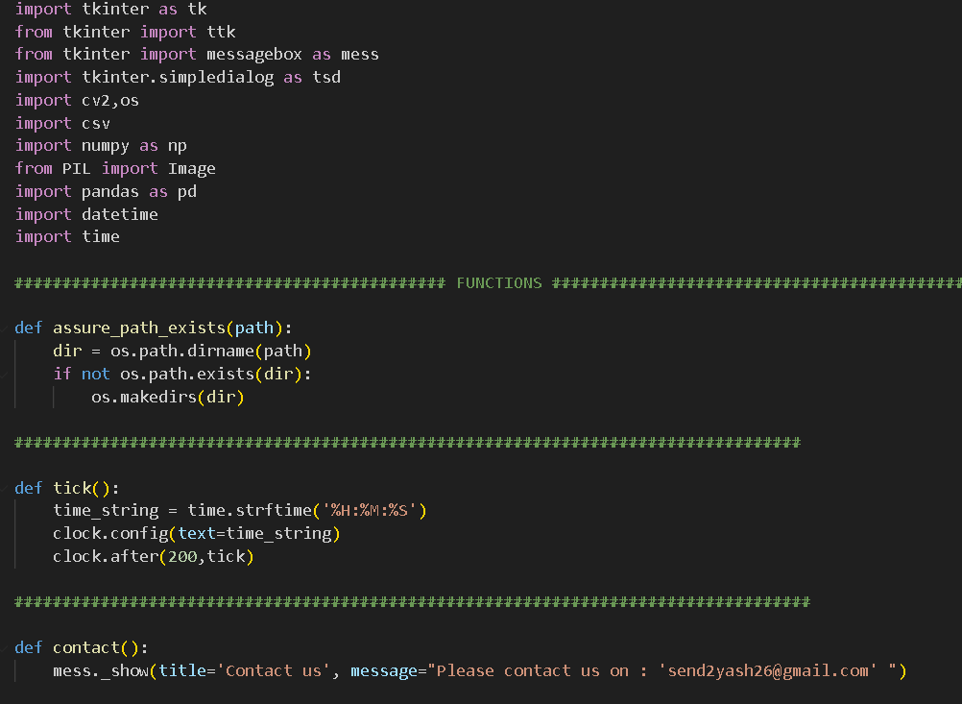 5.1

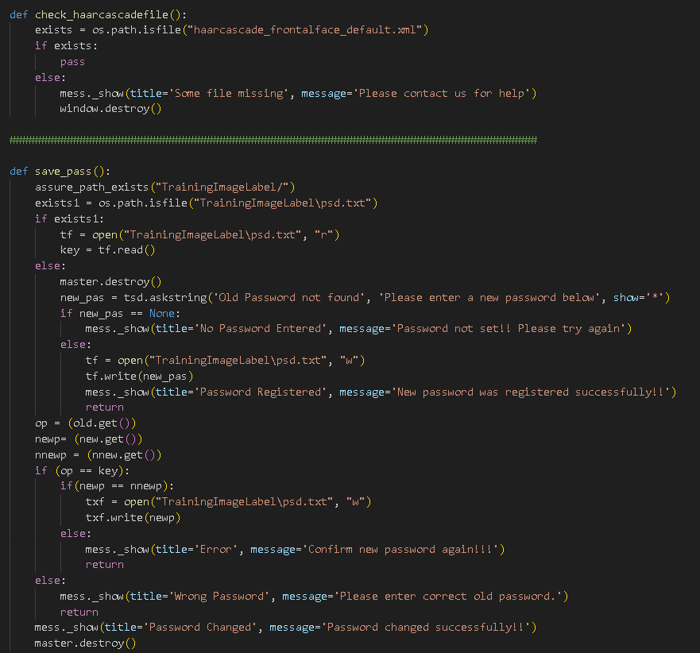 **5.2**

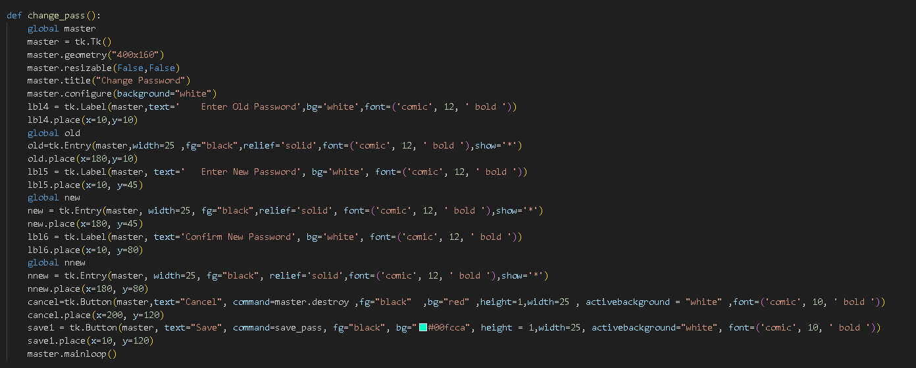 **5.3**

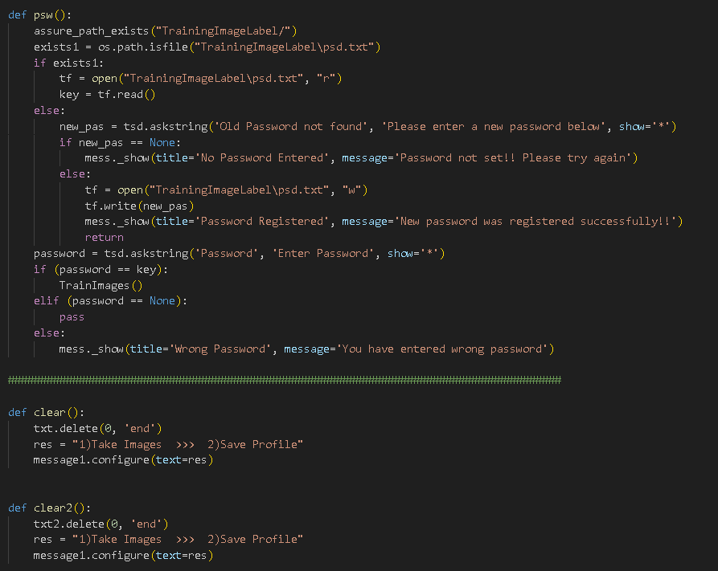 **5.4Results:**

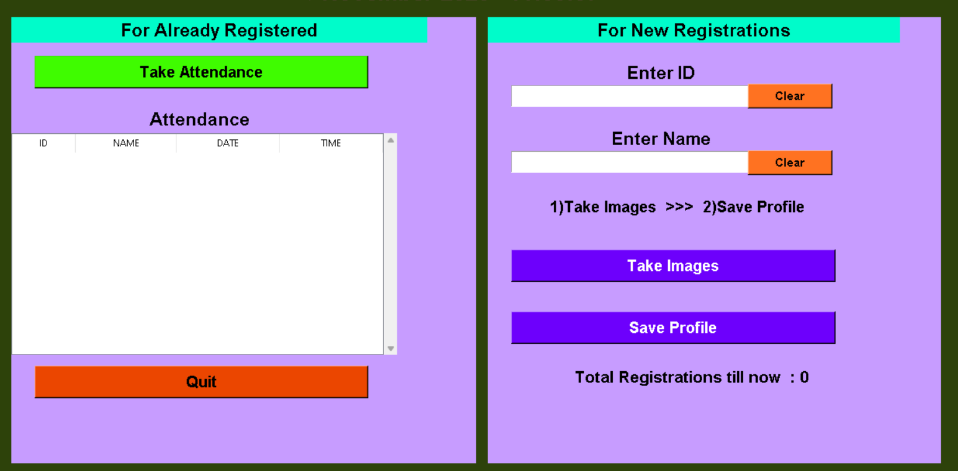 **5.5**

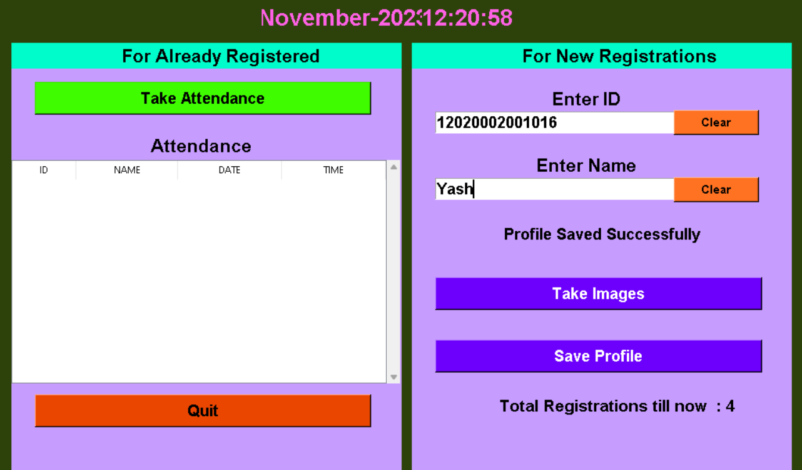 **5.6**

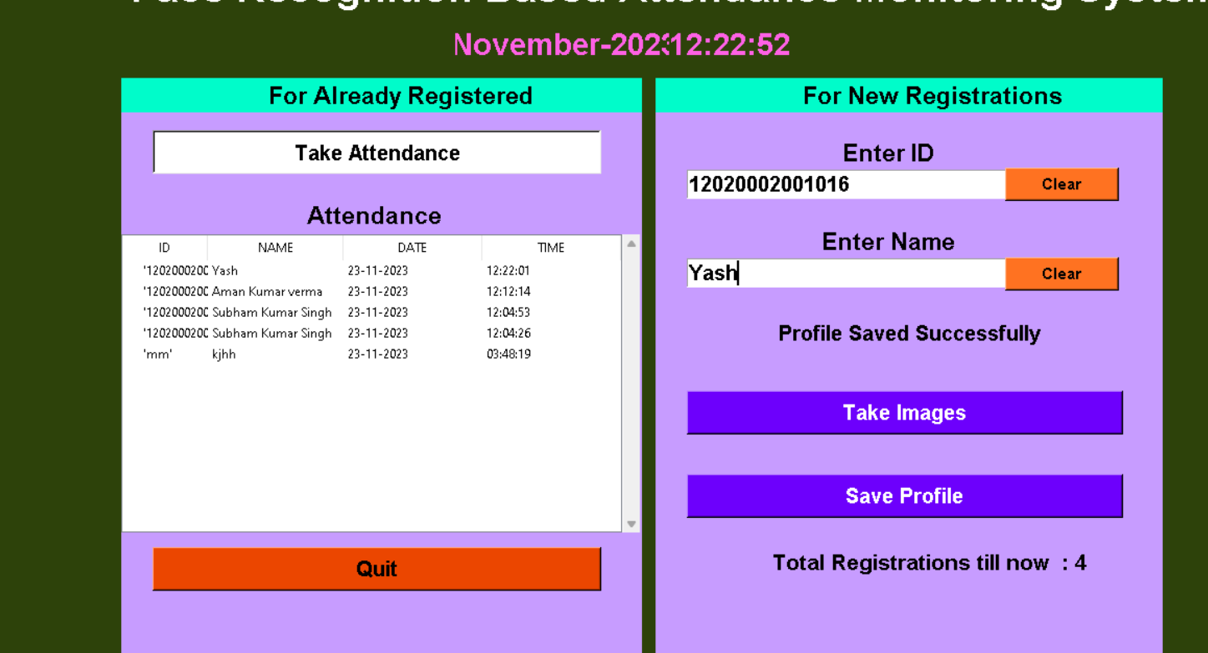 **5.7**

**7.CONCLUSION & FUTURE SCOPE**

**Conclusion:**

In conclusion, the Online Face Recognition Attendance System marks a transformative shift in attendance management paradigms. By leveraging cutting-edge facial recognition technology, the system streamlines traditional processes, offering a modern, accurate, and efficient solution. The successful integration of facial recognition algorithms has demonstrated a substantial reduction in manual efforts, an improvement in accuracy, and a heightened level of security. The real-time processing capabilities, intuitive user interfaces, and stringent security measures collectively contribute to an enhanced experience for both administrators and end-users. The system's adaptability to diverse environments, scalability, and seamless integration with existing systems position it as a versatile and indispensable tool for attendance tracking across various sectors.

**Future Scope:**

Looking ahead, the future scope of the Online Face Recognition Attendance System is rich with potential for further innovation. Continuous algorithmic improvements remain a focal point, ensuring the system's adaptability to evolving facial recognition techniques and enhanced accuracy. Exploring advanced security features, such as multi-factor authentication and liveness detection, can fortify the system against emerging threats. Integration with wearable devices and the development of mobile applications can extend accessibility and usability, offering users a diverse range of options for attendance marking. The exploration of artificial intelligence for predictive insights and collaboration with educational technologies can usher in a new era of comprehensive attendance management solutions. As the system continues to evolve, adherence to biometric data privacy standards and global adoption across industries will be critical, ensuring ethical and legal compliance in an ever-changing technological landscape. In essence, the Online Face Recognition Attendance System stands at the forefront of technological advancement, poised for continuous growth and refinement in the pursuit of efficient, secure, and digitally integrated attendance tracking solutions.